🔢 Part 1: Numerical Data — Master Level Understanding

First — The Shock Statement
ChatGPT told you something very important:

"Every numerical data is NOT
discrete or continuous."

This means:

Some numbers are TRUE numbers → Discrete or Continuous
Some numbers just LOOK like numbers → Actually Categorical

The question is HOW do you tell the difference?

The Root Question to Understand This
When you see a NUMBER ask:

"Is this number here to MEASURE something?
OR is it just a LABEL that uses digits?"

MEASURE → True Numerical → Discrete or Continuous
LABEL → Fake Numerical → Actually Categorical

Story 1 — The Cricket Jersey 🏏
Imagine an Indian cricket team:
Virat Kohli → Jersey No. 18
Rohit Sharma → Jersey No. 45
MS Dhoni → Jersey No. 7
These are numbers. But ask:
"Is Jersey No. 45 GREATER than Jersey No. 18?"
→ In terms of batting skill? NO!
→ In terms of seniority? NO!
→ It means absolutely nothing!

"Can I ADD jersey numbers?"
18 + 45 + 7 = 70
→ Does 70 mean anything? 😂 NO!

"Is there a value BETWEEN 7 and 18?"
→ Nobody wears jersey 12.5
→ But even if they did it means NOTHING

Conclusion:
Jersey numbers are just LABELS using digits.
→ NOT truly numerical
→ Actually CATEGORICAL (Nominal)

Story 2 — Goals Scored in a Match ⚽
Player 1 scored → 3 goals
Player 2 scored → 1 goal
Player 3 scored → 5 goals
Now ask the same questions:
"Is 5 goals GREATER than 3 goals?"
→ YES! 5 goals means more goals scored
→ The number actually MEANS something

"Can I ADD goals?"
3 + 1 + 5 = 9 total goals
→ Does 9 mean anything? YES! Total team goals

"Is there a value BETWEEN 1 and 3?"
→ Can someone score 1.5 goals? NO!
→ Only whole goals possible

Conclusion:
Goals scored is a TRUE number.
It MEASURES actual performance.
→ NUMERICAL → DISCRETE ✅

The Key Difference Is Clear Now
JERSEY NUMBER GOALS SCORED
──────────────────────────────────────
Just a label Measures something real
18 is not > 7 5 is genuinely > 3
Addition = meaningless Addition = meaningful
→ CATEGORICAL → NUMERICAL (Discrete)

Now The Master Framework

3 Tests to Check If a Number is Truly Numerical

✅ Test 1: Does the Number MEASURE Something Real?
Ask: "Does a bigger number actually
mean MORE of something real?"

Age = 30 is MORE years lived than Age = 20
→ YES it measures something real → NUMERICAL ✅

Pin Code: 560001 vs 400001
→ Is 560001 MORE of something than 400001?
→ NO! Just different locations
→ NOT truly numerical → CATEGORICAL ❌

✅ Test 2: Does Addition Give a Meaningful Answer?
Ask: "If I add these numbers,
does the result mean something?"

Salary: ₹40,000 + ₹60,000 = ₹1,00,000
→ Total salary bill = meaningful ✅
→ NUMERICAL

Phone Number: 9845123456 + 9741234567
= 19,586,357,923
→ Means absolutely nothing 😂
→ NOT truly numerical → CATEGORICAL ❌

✅ Test 3: Can You Meaningfully Order Them?
Ask: "If I arrange these numbers
from small to big, does that
ORDER mean something real?"

Temperature: 20°C < 25°C < 30°C < 35°C
→ Order means getting hotter → meaningful ✅
→ NUMERICAL

Student Roll Numbers: 5 < 12 < 47 < 103
→ Does this order mean anything real?
→ NO! Roll 103 is not "more" of anything
→ Just an ID label → CATEGORICAL ❌

Now — The Full Numerical Family Tree
A NUMBER APPEARS IN YOUR DATA
│
▼
TEST 1: Does it MEASURE something real?
│
NO ──────────────────────────→ CATEGORICAL
│ (It's just a label
│ using digits)
YES
│
▼
TEST 2: Does addition give meaning?
│
NO ──────────────────────────→ CATEGORICAL
│
YES
│
▼
It is TRUE NUMERICAL DATA
│
▼
TEST 3: Can values be decimal/fractional?
│
YES NO
│ │
▼ ▼
CONTINUOUS DISCRETE
(Any value possible) (Only whole numbers)
Height, Weight, Goals, Children,
Salary, Temp Orders, Employees

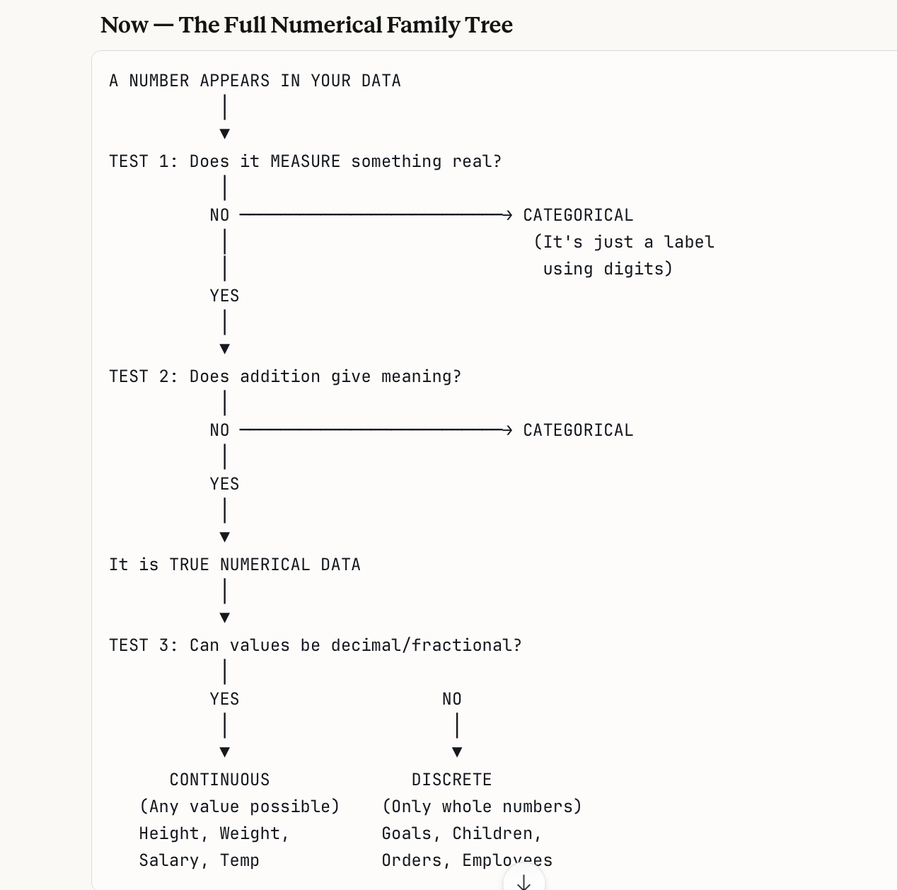

Now Let's Go DEEP on Continuous vs Discrete

Why is this distinction important?
STORY:
A company wants to analyze
"Average number of children per employee"

Result = 2.3 children

Now:
Number of children is DISCRETE
(you can't have 2.3 real children 😄)

But the AVERAGE can be 2.3
This is perfectly fine in statistics!

The data itself is discrete.
But calculations on it can give decimals.

The 5 Deep Questions to Master Continuous vs Discrete

Question 1: "Can the value exist between two whole numbers?"
Temperature between 36°C and 37°C:
→ 36.1, 36.2, 36.5, 36.99°C all EXIST
→ CONTINUOUS ✅

Children between 2 and 3:
→ 2.5 children CANNOT EXIST in reality
→ DISCRETE ✅

Question 2: "Am I MEASURING or COUNTING?"
This is the golden question.

MEASURING → Usually Continuous
COUNTING → Usually Discrete

You MEASURE: You COUNT:
→ Height → Number of people
→ Weight → Number of orders
→ Temperature → Number of goals
→ Distance → Number of rooms
→ Time taken → Number of mistakes
→ Salary (amount) → Number of children

Measuring tape = Continuous 📏
Counting fingers = Discrete 🖐️

Question 3: "What instrument do I use to find it?"
RULER / SCALE / THERMOMETER / STOPWATCH
→ These give you any value including decimals
→ CONTINUOUS

TALLY MARKS / COUNTING
→ These give you only whole numbers
→ DISCRETE

How tall is this building?
→ Use a measuring instrument → 45.7 meters
→ CONTINUOUS

How many floors does it have?
→ Count them → 12 floors
→ DISCRETE

Question 4: "What happens at the boundary?"
CONTINUOUS:
Between 5 feet and 6 feet tall:
5.1, 5.2, 5.3... 5.9 all exist
Infinite values between boundaries
→ Like a smooth ramp 🛝

DISCRETE:
Between 2 and 3 goals scored:
Nothing exists in between
Values jump directly 2 → 3
→ Like a staircase 🪜

Question 5: "Is it about a THING or an AMOUNT?"
Counting THINGS = Discrete
→ Number of customers (things = people)
→ Number of products sold (things = items)
→ Number of complaints (things = complaints)

Measuring AMOUNTS = Continuous
→ Amount of water (amount = litres)
→ Amount of time (amount = hours)
→ Amount earned (amount = rupees)

The Tricky Ones — That Confuse Everyone

Tricky 1: Money / Salary
Salary: ₹45,000 per month

Is it Continuous or Discrete?

ARGUMENT FOR CONTINUOUS:
→ ₹45,000.50 is technically possible
→ Money can have decimals (paise)

ARGUMENT FOR DISCRETE:
→ Salary is usually in whole rupees
→ You don't earn ₹45,000.3271

REAL ANSWER:
→ Money is treated as CONTINUOUS
in data analysis
→ Because it can be subdivided
(rupees → paise → fractions)
→ Even if we round to whole numbers,
the underlying value is continuous

Tricky 2: Age
Age: 25 years old

Is it Continuous or Discrete?

In daily life:
→ "I am 25 years old" sounds discrete

In reality:
→ You are actually 25 years, 3 months,
14 days, 6 hours, 22 minutes old
→ Age flows continuously every second

REAL ANSWER:
→ Age is CONTINUOUS
→ Because time flows without gaps
→ Even if we write it as whole years
the actual value is always changing

Tricky 3: Number of Visits to a Website
Today's website visits: 1,547

Is this Continuous or Discrete?

Can there be 1547.5 visits?
→ NO! Half a visit makes no sense
→ Each visit is a complete event

REAL ANSWER:
→ DISCRETE
→ You COUNT visits as whole numbers
→ No fractions possible

Tricky 4: Exam Score
Exam Score: 78 out of 100

Is this Continuous or Discrete?

If scoring is in whole numbers only:
→ 78, 79, 80 (no 78.5)
→ DISCRETE

If scoring allows decimals:
→ 78.5, 79.25 possible
→ CONTINUOUS

REAL ANSWER:
→ Depends on the exam system!
→ This is why context always matters
→ Always ask: "Can this be a decimal
in THIS specific situation?"

Practice Questions — Test Yourself 🧪
Go through each one. Apply the 3 tests.
Question 1:
Number of likes on an Instagram post
→ Can it be decimal?
→ Are you measuring or counting?
→ Your answer: ___________

Question 2:
Temperature of a cup of tea
→ Can it be decimal?
→ Are you measuring or counting?
→ Your answer: ___________

Question 3:
Your Aadhaar card number
→ Does it measure something real?
→ Does addition make sense?
→ Your answer: ___________

Question 4:
Distance from home to office
→ Can it be decimal?
→ Are you measuring or counting?
→ Your answer: ___________

Question 5:
Number of WhatsApp messages today
→ Can it be decimal?
→ Are you measuring or counting?
→ Your answer: ___________

Question 6:
Blood pressure reading (120/80)
→ Can it be decimal?
→ Does it measure something real?
→ Your answer: ___________

Question 7:
Floor number in a building (3rd floor)
→ Can it be decimal? (2.5th floor?)
→ Does it measure or label?
→ Your answer: ___________

Question 8:
OTP (One Time Password): 4 8 2 9
→ Does it measure something?
→ Does addition make sense?
→ Your answer: ___________

Answers — Check Yourself ✅
Q1: Instagram likes
→ 1547.5 likes? NO
→ COUNTING things
→ DISCRETE ✅

Q2: Tea temperature
→ 72.3°C? YES possible
→ MEASURING heat
→ CONTINUOUS ✅

Q3: Aadhaar number
→ Measures nothing real
→ Addition meaningless
→ CATEGORICAL (Nominal) ✅

Q4: Distance to office
→ 12.7 km? YES possible
→ MEASURING distance
→ CONTINUOUS ✅

Q5: WhatsApp messages
→ 47.5 messages? NO
→ COUNTING things
→ DISCRETE ✅

Q6: Blood pressure (120/80)
→ 120.5/80.3? YES possible
→ MEASURING pressure
→ CONTINUOUS ✅

Q7: Floor number
→ 2.5th floor? NO real floor
→ LABELING floors not measuring
→ Actually CATEGORICAL (Ordinal)
Floors have order but are labels ✅

Q8: OTP 4829
→ Measures nothing
→ 4829 + 7392 = meaningless
→ CATEGORICAL (Nominal) ✅

The Master Summary
NUMBERS IN DATA
│
├── FAKE NUMBERS (Just labels using digits)
│ → Phone numbers, Pin codes,
│ Aadhaar, OTP, Jersey numbers
│ → CATEGORICAL
│ → Fails Test 1, 2, or 3
│
└── TRUE NUMBERS (Actually measure something)
│
├── CONTINUOUS (Measuring)
│ → Flows without gaps
│ → Height, Weight, Temp,
│ Distance, Salary, Time
│ → Uses instruments to measure
│
└── DISCRETE (Counting)
→ Jumps in whole steps
→ Goals, Children, Orders,
Visitors, Messages
→ Uses counting to find

One Line to Remember Forever
Not every number is a true number.

Ask: "Does this number MEASURE
something meaningful?"

YES → True Numerical →
Continuous (measuring) or
Discrete (counting)

NO → Fake Numerical →
Categorical in disguise! 🎭
